Dear participants to the workshop on “Agent-based models of social networks”,

the workshop is approaching and we’re happy to finally be able to share the schedule of the invited talks with you (please see the attached file).

You will all be accommodated at Hotel Bianca Maria Palace. To facilitate your journey, here are our recommended transportation options:

- from Milano Linate airport: take the M4-line underground to “Tricolore”, the nearest station to the hotel

- from Milano Malpensa airport, depending on your arrival time:

1. Take the MXP train to Milano Cadorna station, then transfer to the M1-line underground, change at “San Babila” to the M4-line and get off at “Tricolore"

2. Take the MXP train to Milano Centrale station, then take tram 9, get off at “Cinque giornate”.

- from Milan Bergamo airport: take a coach to Milano Centrale, then take tram 9, get off at “Cinque giornate”.

Taxis charge a fixed fare from airports (please be aware that while Linate is very close to the centre, the journeys from Bergamo and Malpensa may take up to 1 hour). You will find taxis right outside the airports and the train stations. Otherwise, you can call taxis at +39 024040 or via the “InTaxi” app.

The area around the hotel is full of restaurants and cafés, feel free to drop me a message, I’ll be happy to send recommendations.

In case you had any questions, please do not hesitate to contact me. In case you want to communicate with us more quickly, here is my phone number: +39 333 4977852

We are looking forward to welcoming you in Milano!

Best,

Federico (on behalf of Flaminio and Raffaele, cc’ed)

Hotel:

Dear prof  Tolsma,

You should already have received an email from Gattinoni Travel with your flight details. Can you kindly confirm that you have received the booking confirmation?

Please keep in mind that you need to keep and send us your boarding passes (paper or PDF file or screenshot of the QR code if you are checking-in with a smartphone app) for admin purposes.

A room has been reserved for you (IN 21/4 OUT  24/4/2024) at:

[Biancamaria Palace Hotel](https://eur01.safelinks.protection.outlook.com/?url=https%3A%2F%2Fwww.biancamariapalace.com%2Fen%3F_gl%3D1*1xieq2d*_up*MQ..*_ga*NDI3MDg5NTcuMTcxMjg1MTQ2Mw..*_ga_JYQSF629H2*MTcxMjg1MTQ2Mi4xLjAuMTcxMjg1MTQ2Mi4wLjAuMA..*_ga_3R5SJEDWK4*MTcxMjg1MTQ2Mi4xLjAuMTcxMjg1MTQ2Mi4wLjAuMA..&data=05%7C02%7Cjochem.tolsma%40ru.nl%7Ca6806206a5ef401b41aa08dc5ad58390%7C084578d9400d4a5aa7c7e76ca47af400%7C1%7C0%7C638485120274271755%7CUnknown%7CTWFpbGZsb3d8eyJWIjoiMC4wLjAwMDAiLCJQIjoiV2luMzIiLCJBTiI6Ik1haWwiLCJXVCI6Mn0%3D%7C0%7C%7C%7C&sdata=s2YrD96rPVDldKb0Tryhj3RmyxOk8ODcCRIbY9JDp5U%3D&reserved=0)

|  |  |  |
| --- | --- | --- |
| Viale Bianca Maria, 4, 20129 – Milano |  |  |
| |  |  | | --- | --- | | **M.** | [booking@biancamariapalace.com](mailto:booking@biancamariapalace.com) | |  |  | | **T.** | [+ 39 02 8342 7500](tel:+%2039%2002%208342%207500) | | **W.** | [www.biancamariapalace.com](https://eur01.safelinks.protection.outlook.com/?url=https%3A%2F%2Flinkprotect.cudasvc.com%2Furl%3Fa%3Dhttps%253a%252f%252fwww.biancamariapalace.com%252f%26c%3DE%2C1%2CqspNai1OdRQDvtUl_I6fQceCZgIG2MklAtw2JRd1XnWZzXhmPiMNTxmZEVvdSYztoO8QAq8DTFcpuWp4RZR8NhDkyZ8w8_DTsMgwv8ALlfpxSkHtDcILdvs%2C%26typo%3D1&data=05%7C02%7Cjochem.tolsma%40ru.nl%7Ca6806206a5ef401b41aa08dc5ad58390%7C084578d9400d4a5aa7c7e76ca47af400%7C1%7C0%7C638485120274282228%7CUnknown%7CTWFpbGZsb3d8eyJWIjoiMC4wLjAwMDAiLCJQIjoiV2luMzIiLCJBTiI6Ik1haWwiLCJXVCI6Mn0%3D%7C0%7C%7C%7C&sdata=8FU0IZEHtCZiD1DxCo1TPuldjdrImURwLm50GNzrCt0%3D&reserved=0) | | | |

For payment of the extra night of 23 April, please contact Mr. Lorenzo Negroni at the following email [sales@biancamariapalace.com](mailto:sales@biancamariapalace.com).

The cost of the room is 170.00 euro, including tourist tax.

Best regards,

Daniela Tagliaferro

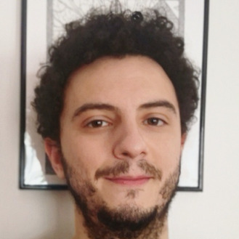

Federico Bianchi <https://www.unimi.it/en/ugov/person/federico-bianchi1>

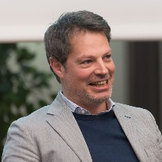

**Flaminio Squazzoni**

<https://www.unimi.it/en/ugov/person/flaminio-squazzoni>

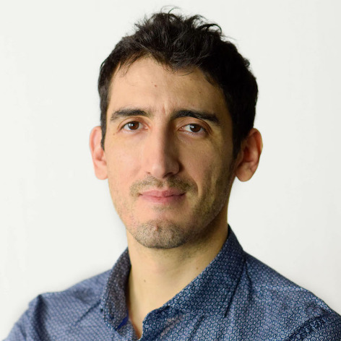

# Raffaele Vacca

# <https://www.unimi.it/it/ugov/person/raffaele-vacca>

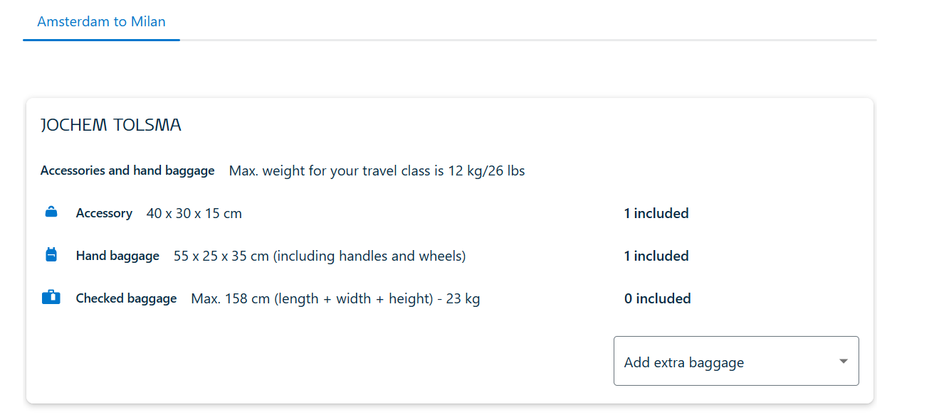

Francesco Renzini

* Dataset of Renzini?. Going togehter to market to buy anti-malaria cream